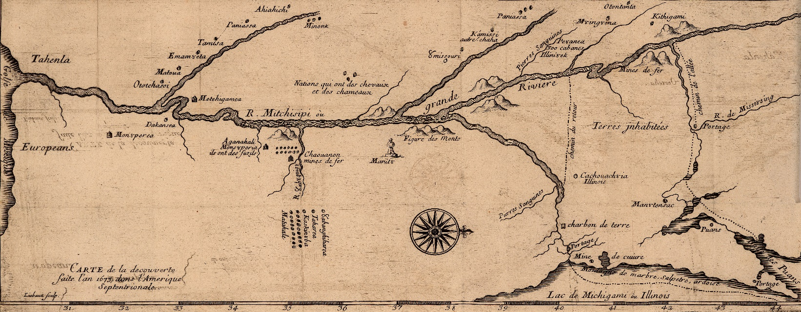

**Home Vita Publications Public Talks Consulting & Media Contact**

**Contact Me!**

Interested in contacting me? Please do!

I am always eager to talk, whether it is about media appearances, public talks, or consulting opportunities. See my contact information below or click here to email me.

Dr. Patrick J. Jung

Milwaukee School of Engineering

1025 N. Broadway

Milwaukee, Wis. 53202-3109

Phone: 414-277-7257

Email: jung@msoe.edu